|  | Jorge Blanco Rey  Ángel Casanova Bienzobas  S.Xiao Fernández Marín | jorge.blancor@estudiante.uam.es  angel.casanova@estudiante.uam.es  sofiax.fernandez@estudiante.uam.es |
| --- | --- | --- |

**TEST PLAN AND TEST RESULTS**

*Application: Citicide*

DATE: May 7th, 2020

**1. TEST CASE: SEARCH GROUP**

* 1. **Use Case:** Search Group

*1.1.1 Primary actor: Registered User.*

*1.1.2 Stakeholders and goals:*

*• Registered User: To enter in the “Group” menu interface, where he can make all*

*the actions related with a group, as individual or if he is a group owner, he can*

*access to all the functions of the group, taking those actions in name of the whole*

*Group.*

*• Administrator: He can check the behavior of the groups to decide whether ban a*

*user or not.*

*1.1.3 Preconditions: The user is identified by the login use case.*

*1.1.4 Success Guarantee (Postconditions): The user could display all the groups that he*

*belongs to, also he could search a new group to log in and access any possible action related with group management through this menu.*

*1.1.5 Main Success Scenario:*

*1. The user selects the “Groups” tab.*

*2. The user selects a group (if any) or searches for a new one.*

*3. The user can join the group.*

*4. The user displays the information of the group.*

*1.1.6 Extensions (Alternative paths):*

*I. The user joins a new group.*

*a) The system decides if the user can enter in the group or not.*

*b) The system displays a new group in the current groups list.*

*II. The user leaves a group.*

*a) The system erases a group from the current group list.*

*III. The user creates a new group.*

*a) The user fulfills the information about the group.*

*b) The system promotes the user from register user to group owner.*

*c) The group is included in the database and it is ready to anyone that wants to join in.*

*IV. The user can see the affinity between two groups (only if he belongs to both*

*groups).*

*a) The system displays the affinity coefficient or an error.*

*1.1.7 Technology and Data Variations List:*

*• Option to search new groups.*

*• Option to display data about the groups that the user belongs to.*

*• Option to display the Affinity Report.*

*• Option to join/leave groups.*

*1.1.8 Frequency:*

*• Very high, in order of hundreds per current users.*

*1.1.9 Open Issues:*

*• In a future version the group may be expanded, so it is possible to append new*

*extensions to this main menu.*

From all the possible scenarios, we are going to test the path of the main success one.

**1.2. Test case design** (including expected inputs and outputs)**:**

**Preconditions:**

The system already has the user “Jorge” accepted by the administrator, and the group “Videogames” and subgroup “Zelda” created by other user.

1. The system shows the login window.

2. The user types his user name, “Jorge”, with the password “j” and clicks on the “Log in” button.

**Scenario:**

1. The system shows a panel which includes the user’s groups.

2. At the left side of the window the user finds a combo box.

3. The user clicks on the combo box and appears a list with “Your groups”, “Voted Projects”, “New groups”, “New projects” and “Your notifications”.

4. The user clicks on the “New group” label, where all the existing groups and subgroups appear. Since, they are treated equally, because at the end a subgroup is also a group.

5. It appears a list with all the projects that the system has.

6. To see the information of a group the user must click on one of them.

7. The user clicks on the “Videogames” group to see its information.

8. At the left-top corner the user pushes the “Join group” button.

9. It appears a pop-up saying “You have joined the group correctly”.

11. The user clicks on the “OK” button.

12. To check if the user has joined correctly to the group, he goes to the “Your groups” label of the combo box and sees that the group “Videogames” group is there.

**1.3. Test execution result**

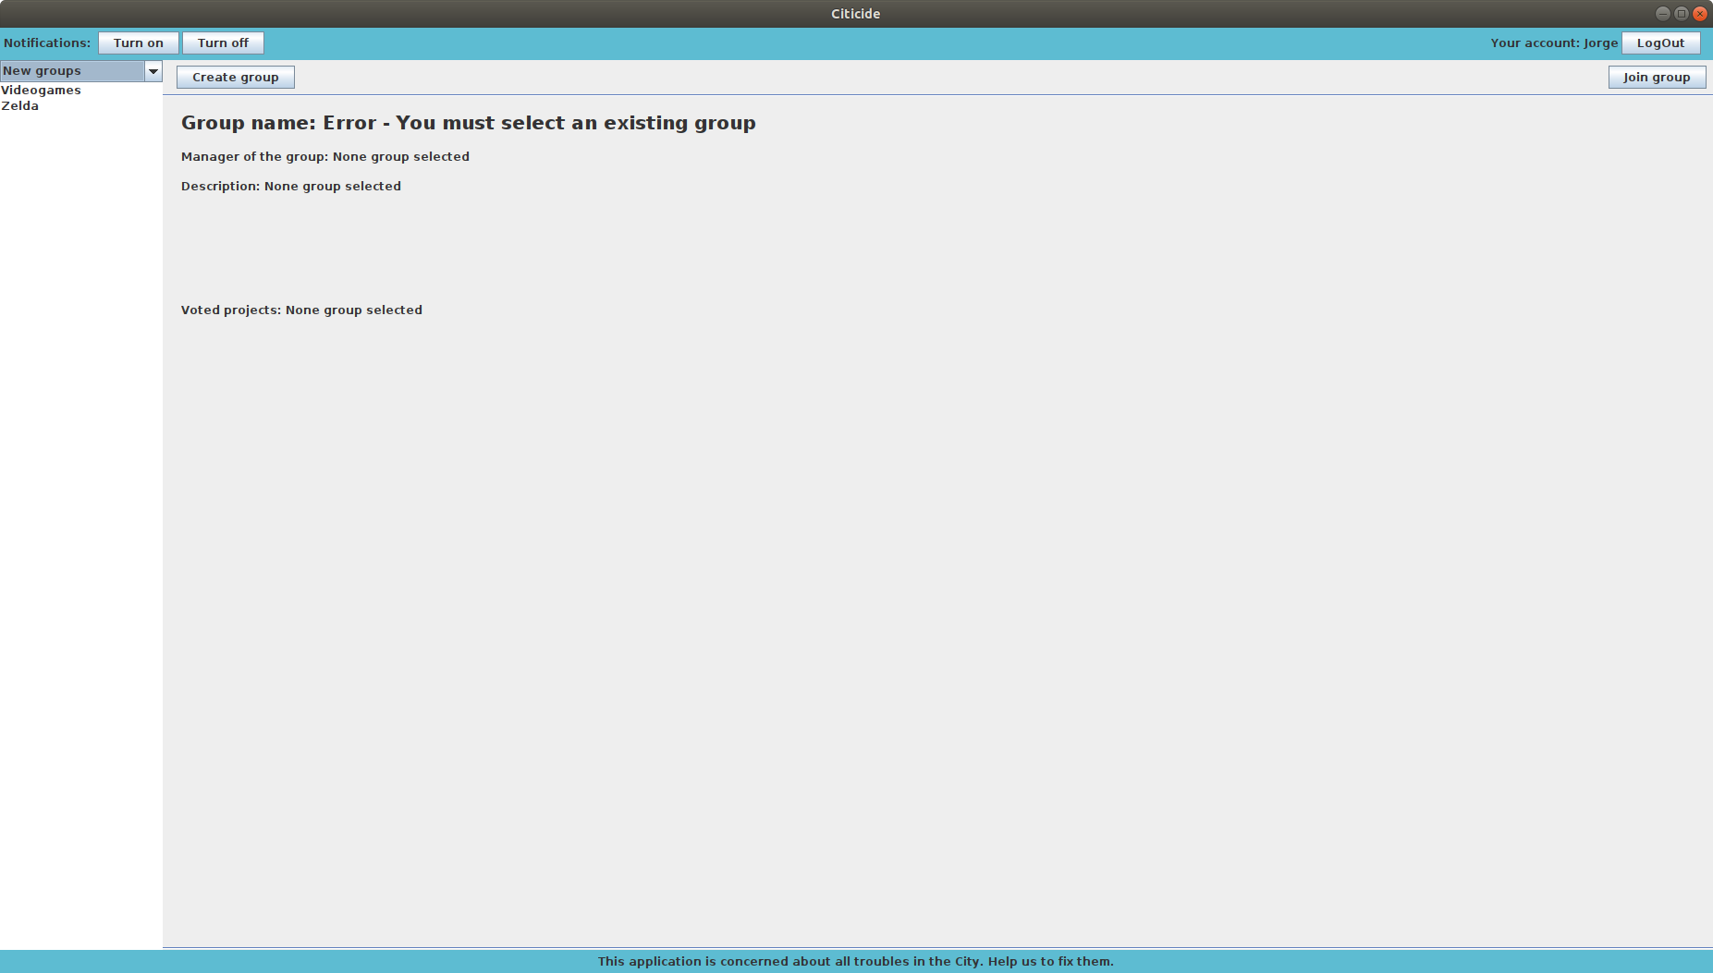

The user is in the “New groups” page, where he must select a group to see its information and join it. This window already has some groups created by other users as expected.

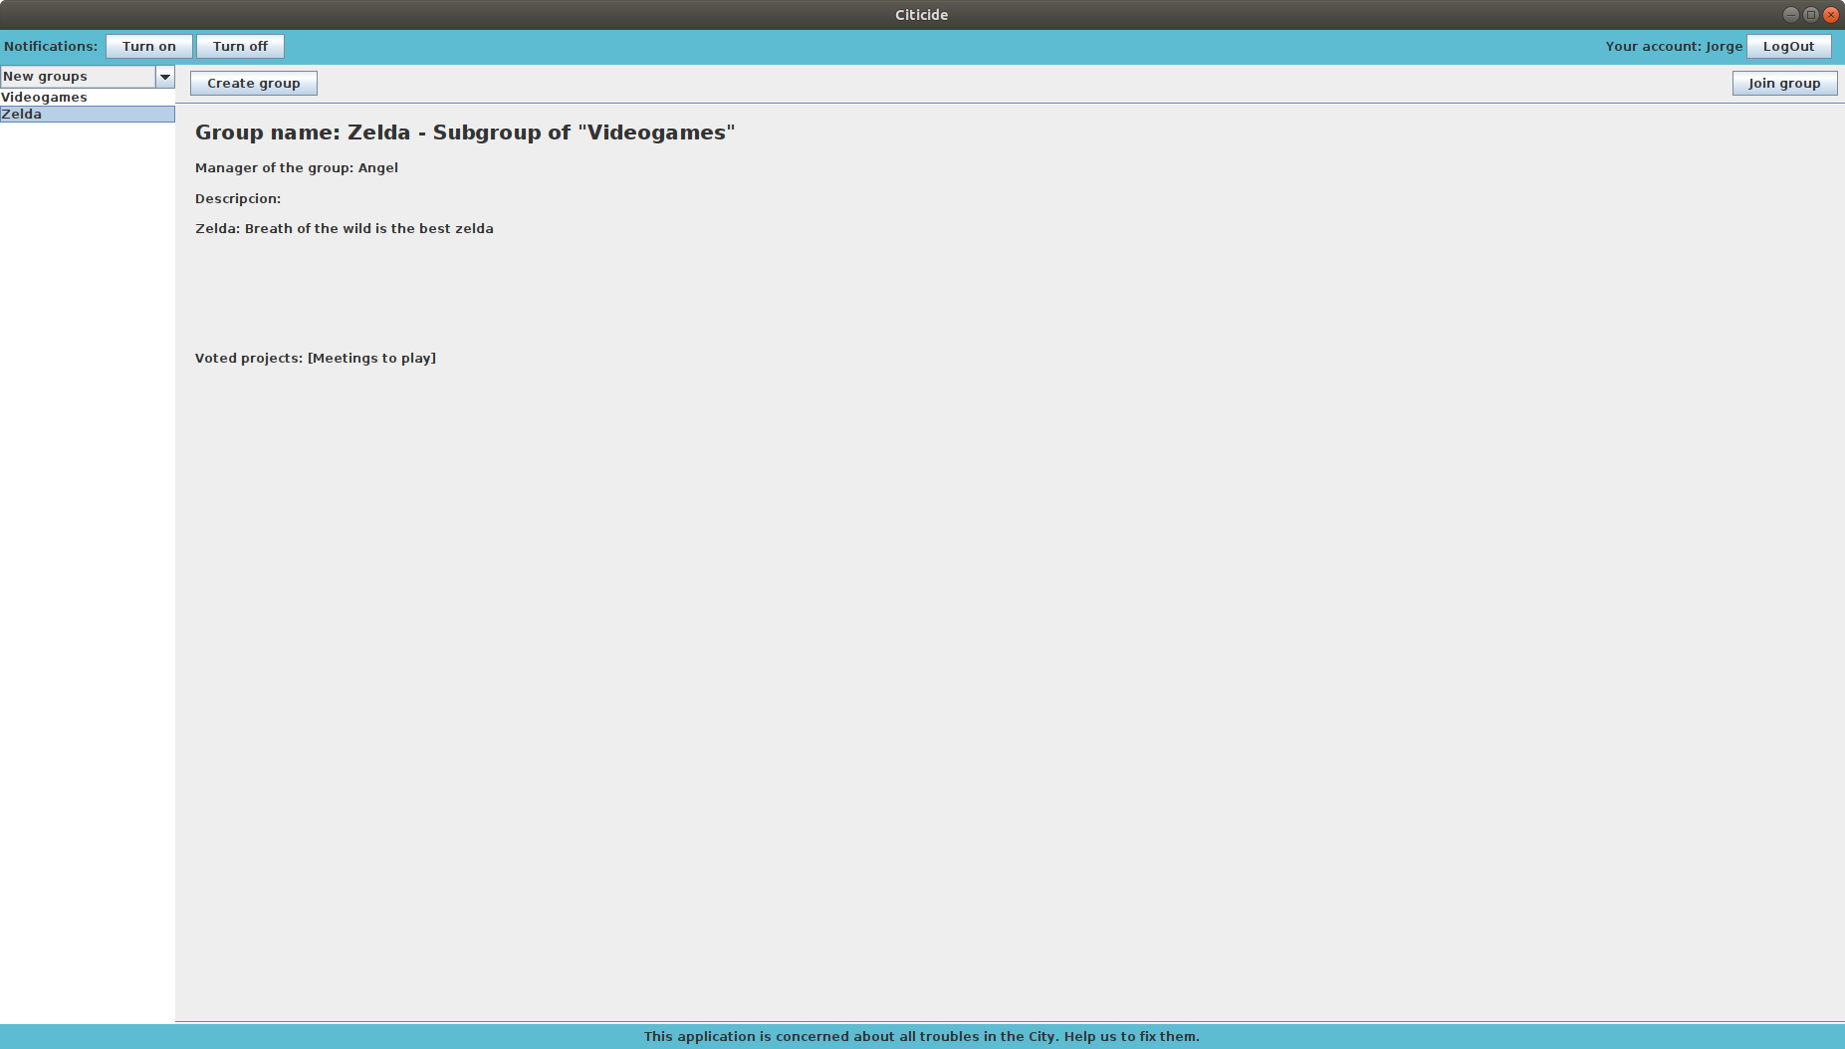

The user selects a group to see its information. As we expected, we can see the manager of the group, its description and voted projects.

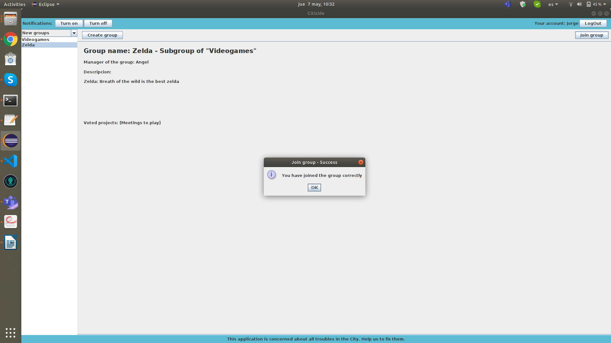

The user clicks on the “Join group” button for joining the selected group, in this case, “Videogames”. Since the current user is not a member of the group, as we expected, the system lets him join the group.

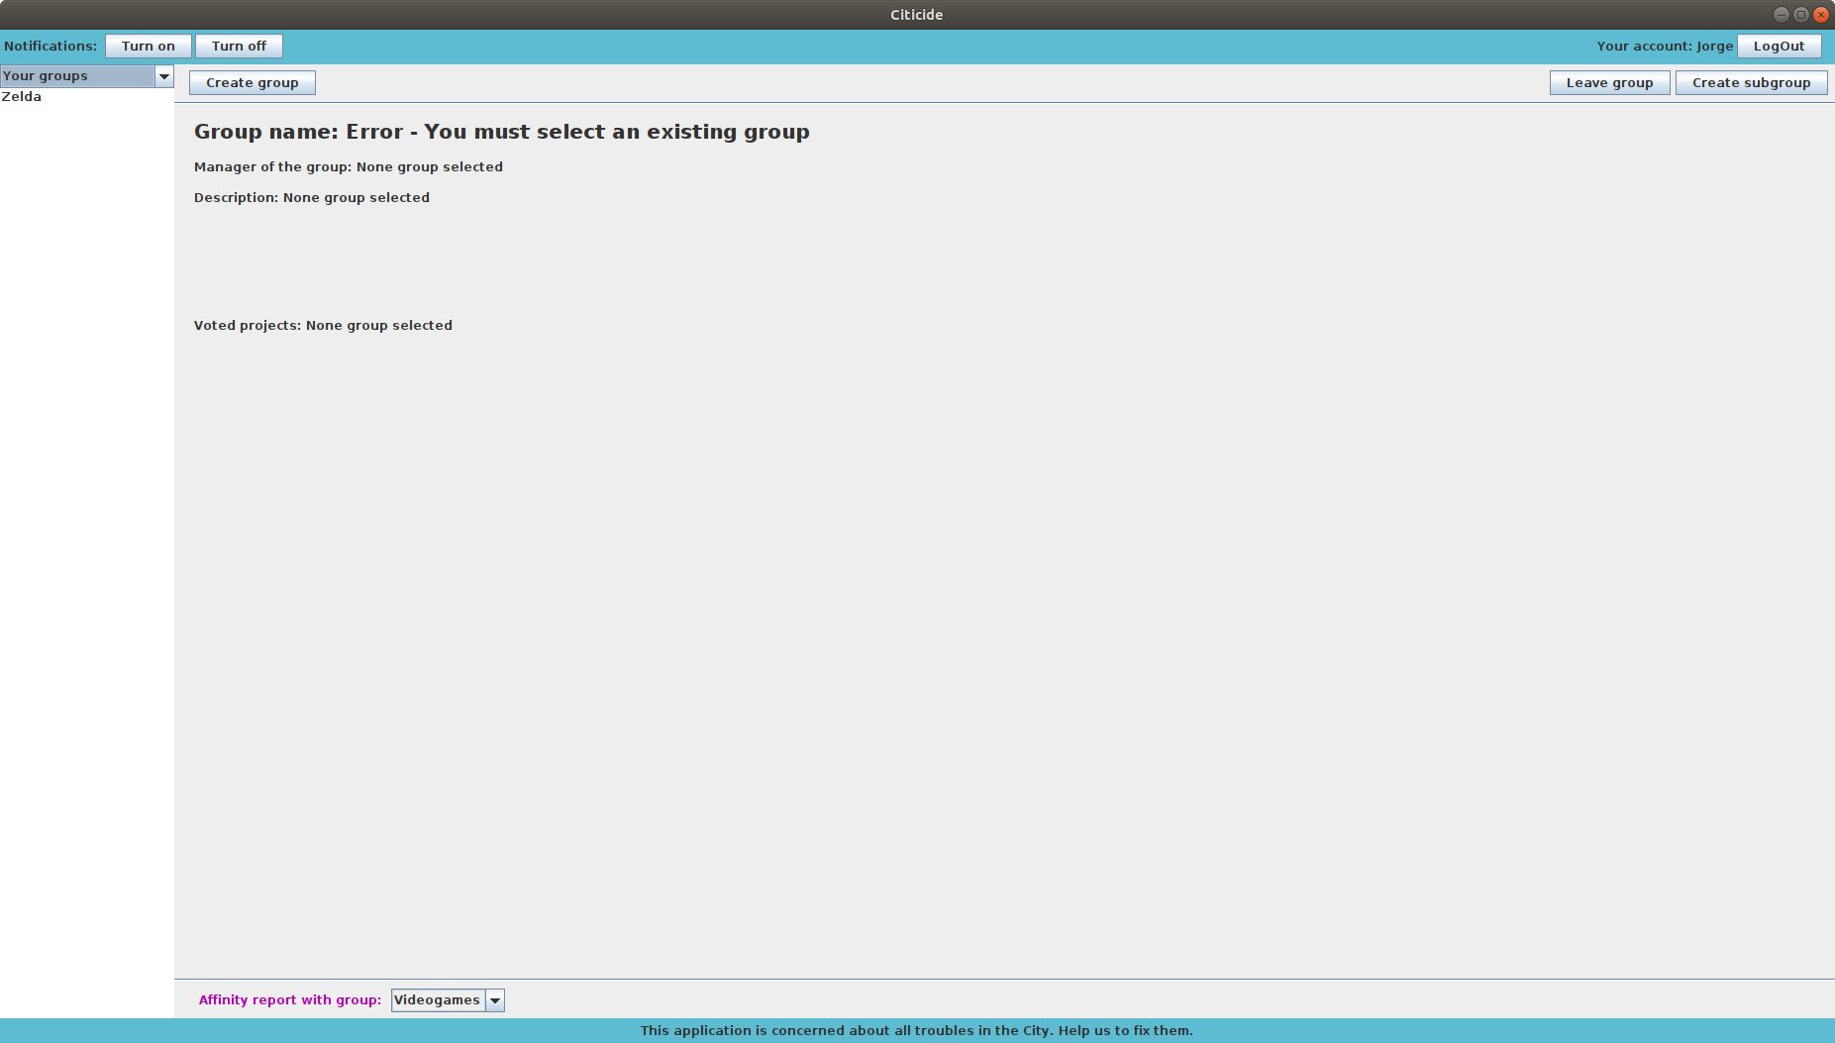

Then, if the user goes to “Your groups” page, where the group he has joined appears instantly, as we expected.

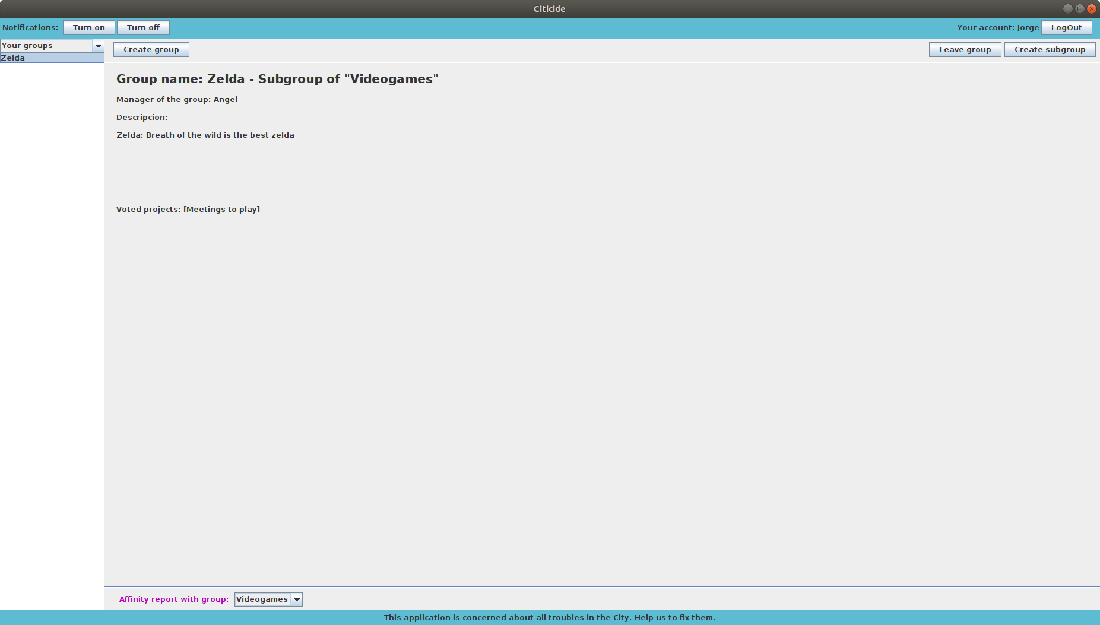

If the user selects the group he has joined, he can see its information. It happens the same as in the “New groups” page when clicking on a group, as we expected.

As a conclusion, in this part we can see that everything works correctly, we can check it observing that the screenshots provided have the same result as the main scenario we described.

**2. TEST CASE: CREATE PROJECT AS A MANAGER**

* 1. **Use Case:** Name of Use Case to be tested

*1.1.1 Primary actor: Registered User.*

*1.1.2 Stakeholders and goals:*

*• Register User: He must be a project owner, if not, an error pop-up will show a warning to the user. If he is a group owner, he will enter in the “Project” menu interface, where he can make all the actions related with a project, as a collective leader and also he can send the project to an external organization, then he can check the status of the project by an ID given by this organization, as a normal user.*

*• Administrator: Must accept or reject a new project, when it is created, he must also decide the minimum number of votes that the project needs in order to be sent to the organization.*

*1.1.3 Preconditions: The user is identified by the login use case, and he must be the owner of at least one group.*

*1.1.4 Success Guarantee (Postconditions): The user creates a project, in the name of a group that he owns, so the project will have the name of the group and will start with a number of votes equal to the number of users that the group has.*

*1.1.5 Main Success Scenario:*

*1. The group owner presses the create project button.*

*2. The group owner selects the “as group owner” option.*

*3. The group owner fulfills the information about the project.*

*4. The group owner waits for the administrator to accept the project.*

*1.1.6 Extensions (Alternative paths):*

*• In this case, they are not any extension to the use case.*

*1.1.7 Technology and Data Variations List:*

*• Option to create a project as collective.*

*1.1.8 Frequency:*

*• Very low, in order of one quarter per current user.*

*1.1.9 Open Issues:*

*• We do not think about future improvements in this use case.*

From all the possible scenarios, we are going to test the path of the main success one.

**1.2. Test case design** (including expected inputs and outputs)**:**

**Preconditions:**

We already have the “Bridge” and “Quarantine” projects created by other users. We also have the group “Meetings to play” created by the “Zelda” group.

As the user we have chosen (Angel) is manager of the groups “Videogames” and “Zelda”, he can create a project as a manager.

1. The system shows the login window.
2. The user types his user name, “Angel”, with the password “a” and clicks on the “Log in” button.

**Scenario:**

1. The user goes to the “voted project menu”
2. The user click on the new project button
3. The user specify that he is a manager of the desired group
4. The user fulfills all the fields(title, description...)
5. The user creates a new project
6. The system sends it to the administrator.
7. The administrator admits (and gives it a minimum number of votes) or rejects the project.
8. The system sends a notification to the manager with the ID of the project.
9. If the project is admitted, the system sends a notification to all the group members, indicating that they have voted to the project “x” by belonging to the group “y”.
10. Now the project is visible in the “new project” menu to anyone and in the “voted project” for all the groups members

**1.3. Test execution result**

First, you need to log in(for example, you can use the user: Angel with password a), in that moment, you will see that pane:

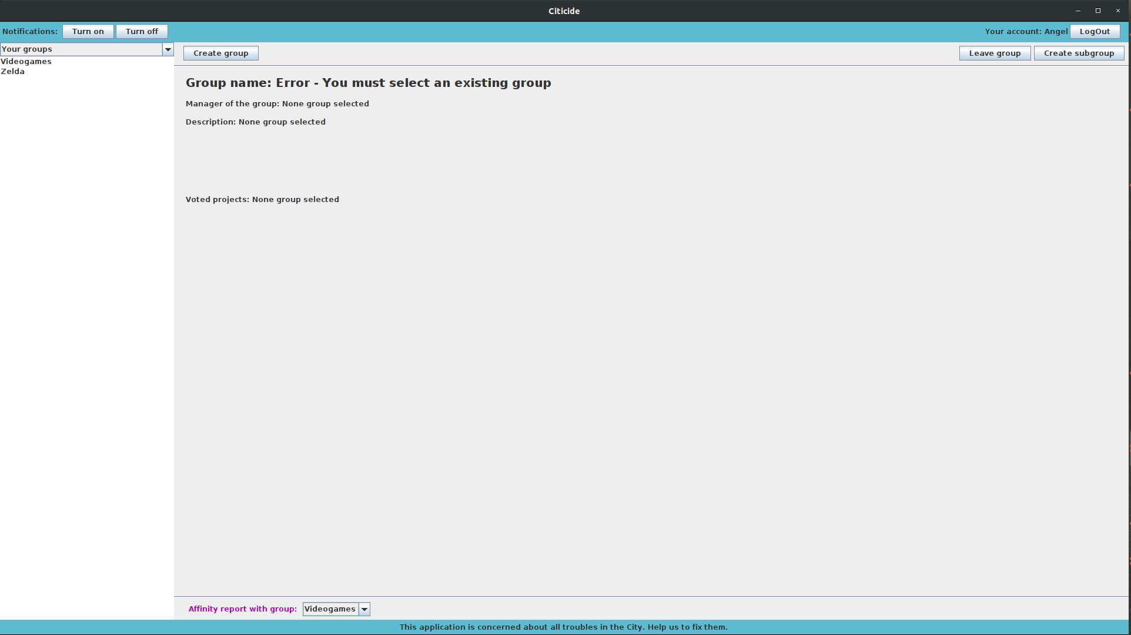

Then you have to click on the left-top combo-box and select the “voted projects” menu. Once there, in the top-right side of the pane, there are two buttons: “Create infrastructure project” “Create social project” , you can choose any of them, when you clicked on them, this pop up will allow you to fulfill all the fields of the group.

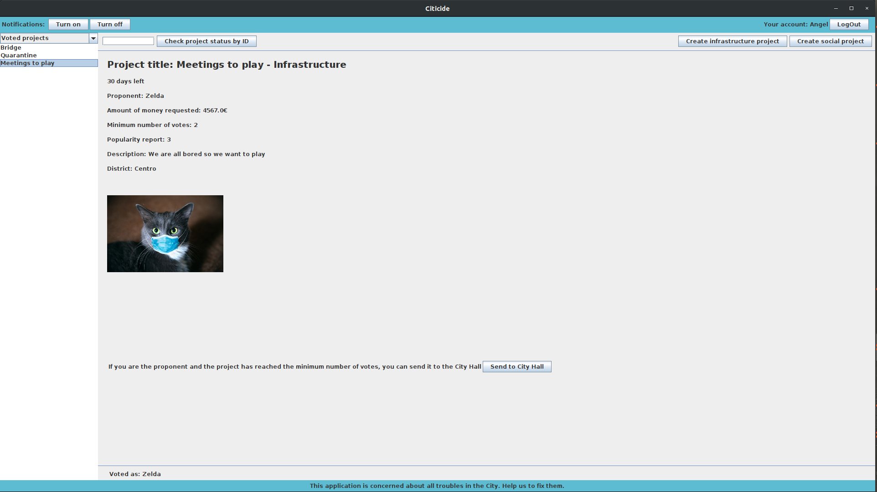

Is important that, in the first combo-box of the pop-up, you select the group that you want to create the project with, because otherwise you will create the project as an individual.

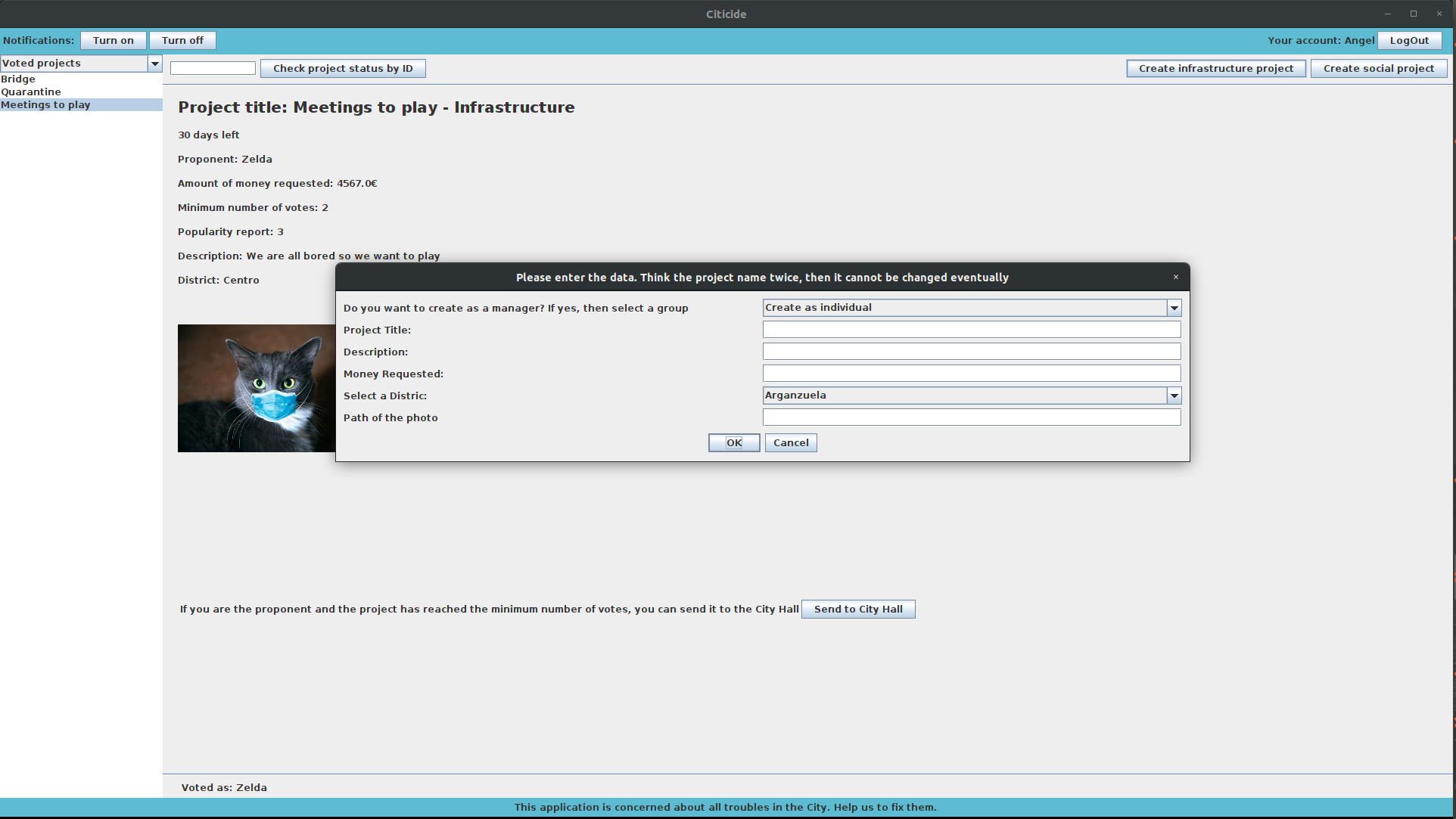

If you fulfill all the fields ok, (this is an example with all the field fulfilled in the proper way:)

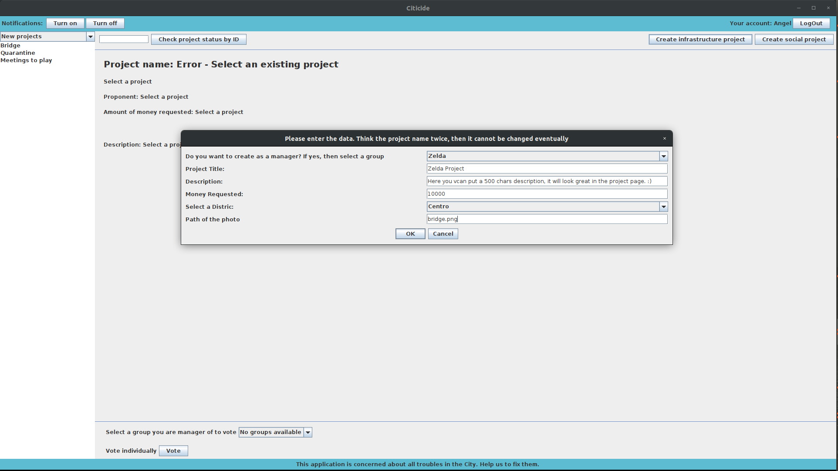

You will be shown this pop-up, otherwise, an specific error pop up will appear.

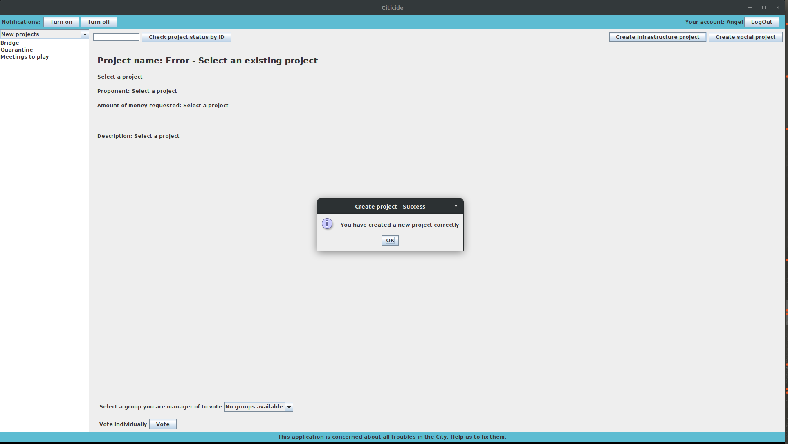

In the next step you need to LogOut(right-top button) and login as the Administrator (user: Juan, password “uameps”), then in the pending project menu (see screenShot), you must admit the project and give it a minimum number of votes.

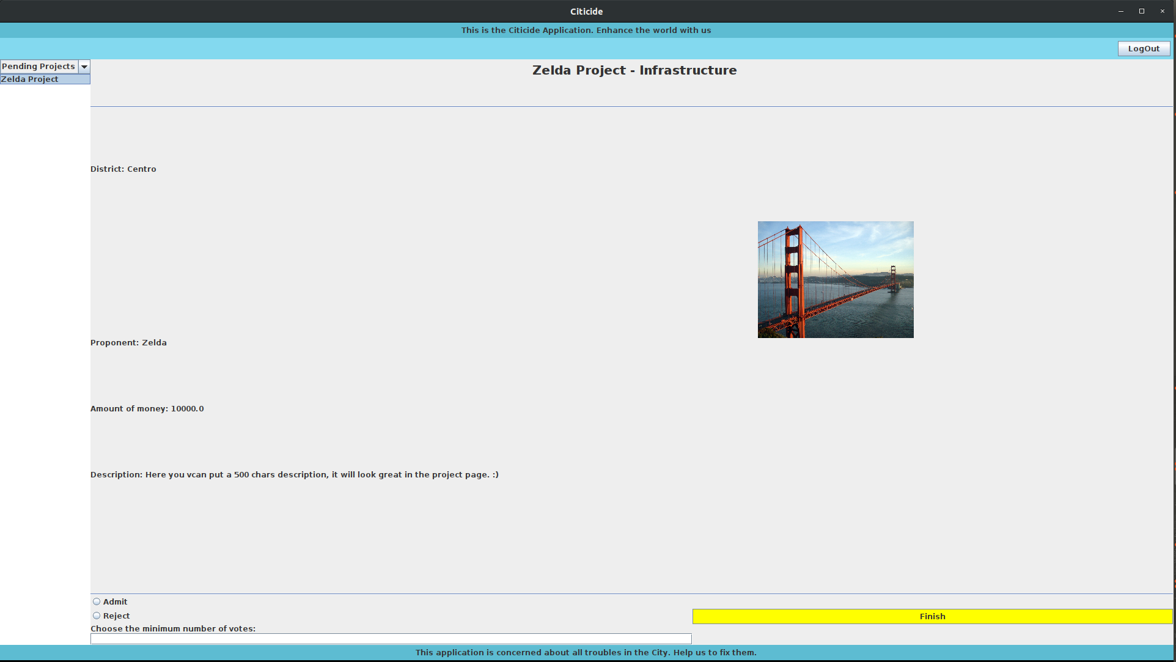

When you click in Finish (if you admit the project you also have to specify the minimum number of votes to the project ), a pop up will confirm that to you:

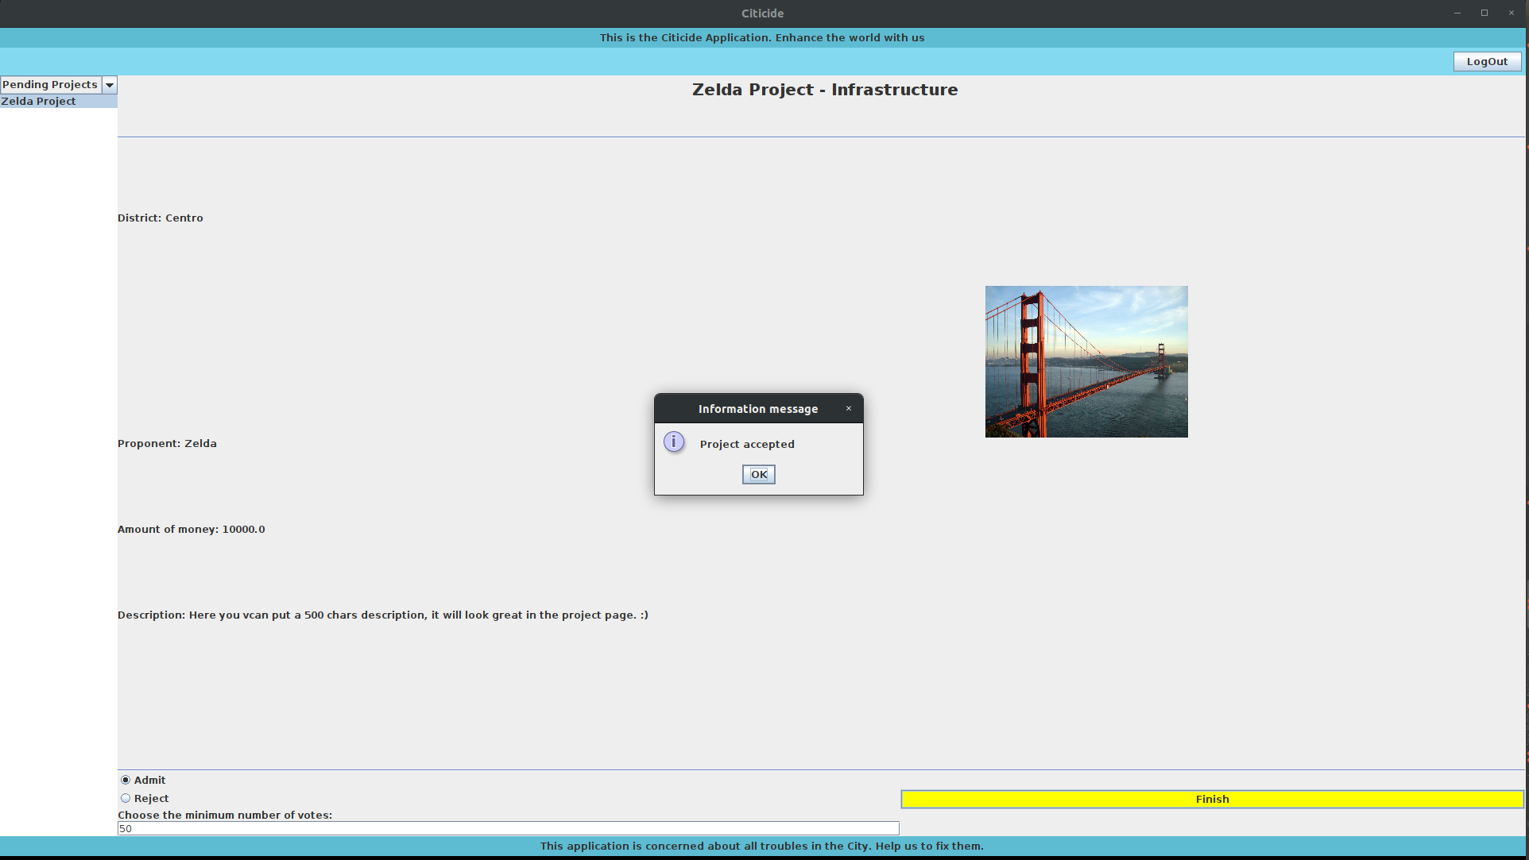

Also, at this moment you can go to the user page and see that you as a manager has received two notification, the rest of the group members just one, because only the manager receive the ID (Our project id, is generated by a hash function, so it could be a negative integer that is not an error).

And in the user menu “Voted project”, now appears the new project that we have just created as a manager, with all the information about it.

This is the final project created by a manager:

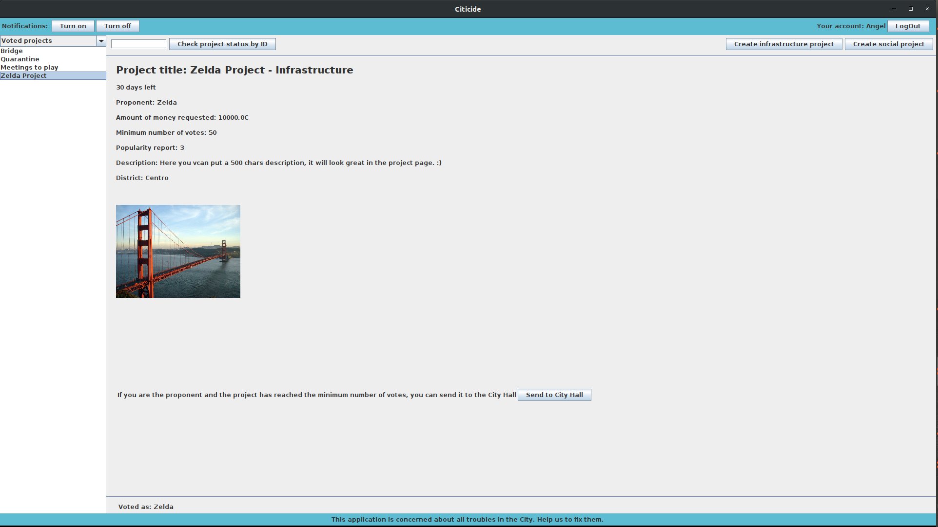

1.3.2 Results:

To sum up the behaviour of the system while creating a new project as a manager of one group, we can observe through the screenshots that the program gives as the expected output, albeit we have fixed two visual bugs (see below).

We reckon that all the procedures work fine due to the fact that the processes give a smooth response (without lag among the different actions).

Bugs found while testing:

1. In the Controller, between lines 172 and 173, we have added this line:

if(p.isAccepted() && !p.isExpired()) { // Only show accepted project to the users

Because otherwise, a visual Bug will appear(in the votes project page you could see the projects before they will be accepted by the administrator (this bug only happened if the project were created as a manager)).

1. In the projectPage, line 699 we send a notification with title “New project” +title” we have to change it to “project” +title , in order to make a distinction between others with the same name.

Also in the line 705, we send the notification to an array of Users called “to”, but that is incorrect, we should put “toM”, it is a different array of Users, so the notifications were not send properly.